LAB MST
UID: 24BCY70145
SUBJECT: COMPUTER NETWORKS
SECTION: 24AIT_KRG_G2(A)

Ans1)
1) Connect 4 routers,
4 switches and
8 PCs
in the topology as shown in the Pic

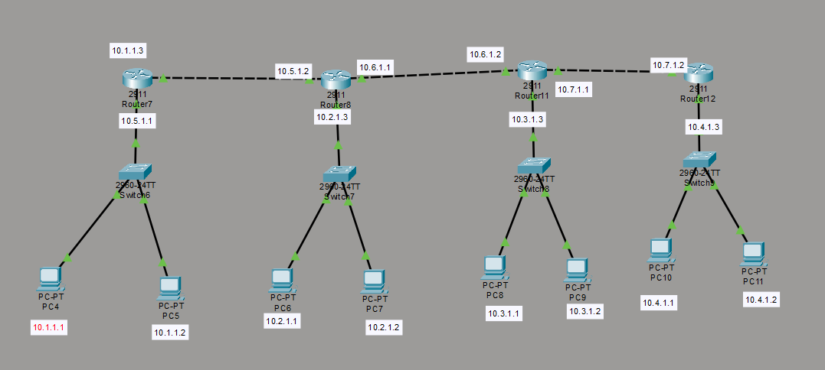

2) Assign the IP address to the PCs and router and gateway IPs as shown in the Pic with subnet mask 255.255.0.0

3) Configure the Static routing of the Router 1 (shown in image) by giving the network Address of all the other Networks connected with their subnet mask 255.255.0.0 with next hop at 10.5.1.2
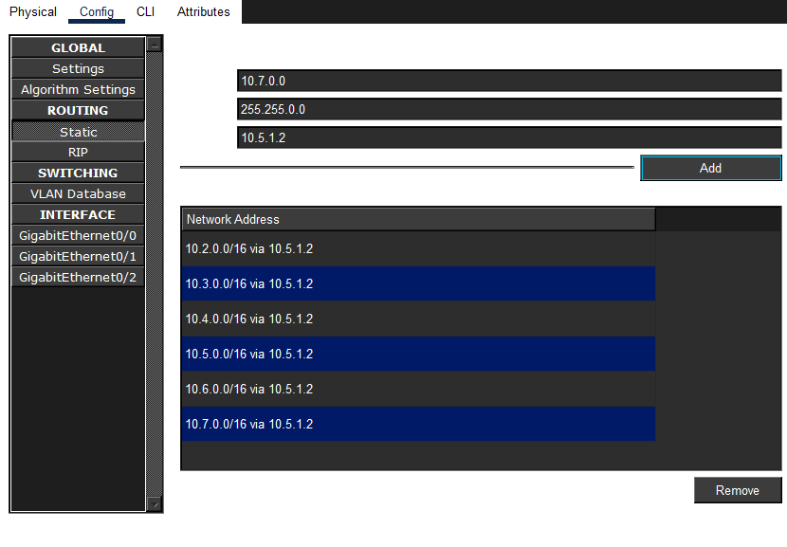
4) Do the same for router 2, 3, 4 with the network address as shown in the Pic 3, 4, 5 respectively
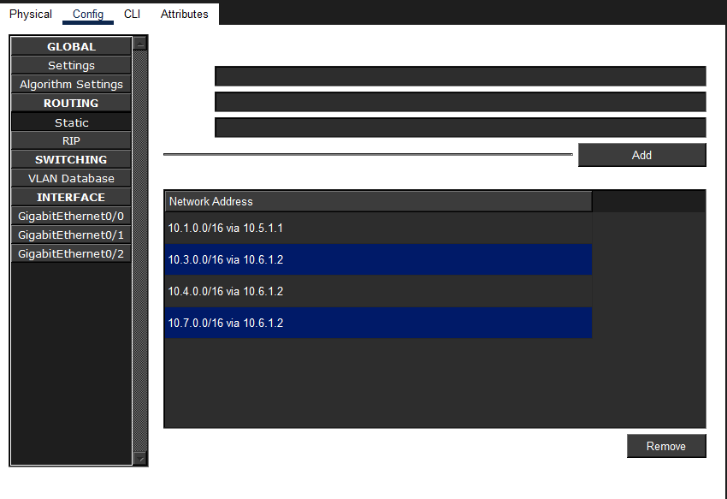
Pic 3
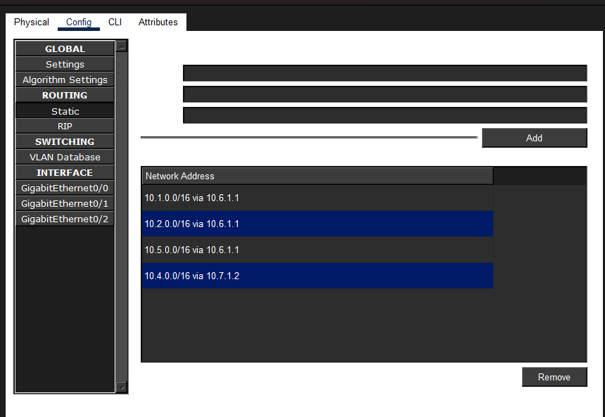
Pic 4
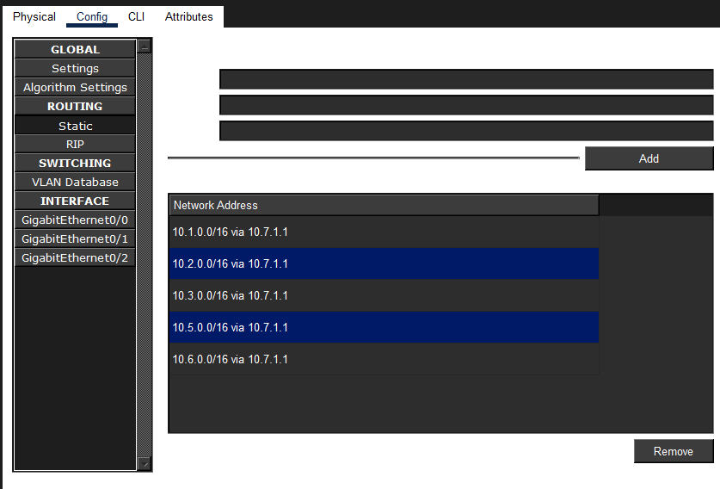
Pic 5
Step 5: Check the connections.
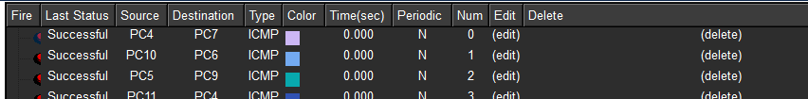

Ans 2)
1) Connect 6 PCs and 1 switch in the topology as shown in the Pic
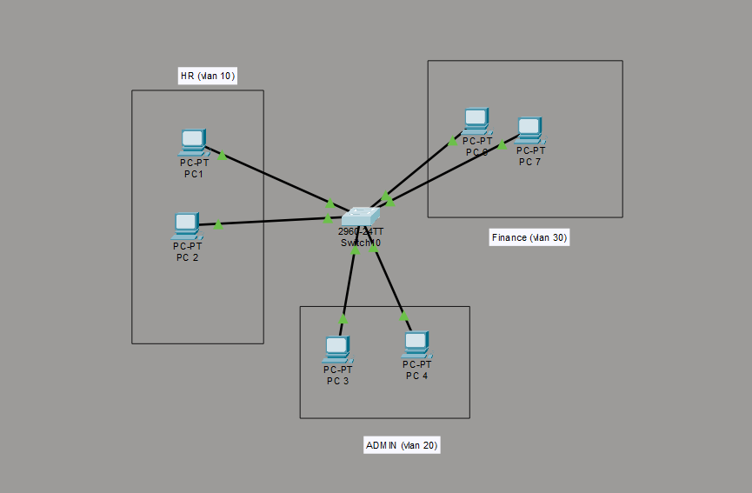
2) Create vlan HR, ADMIN, and Finance with vlan IDS 10,20, and 30 respectively using the following commands in the privileged config mode
->vlan <Vlan Id>
->name <Enter Vlan Name>
for example

vlan 10
name HR

3) Assign HR vlan to fa0/1, and fa0/2 , and Admin vlan to fa0/3, fa0/4, and Finance fa0/5, and fa0/6 using the following commands in privileged config
->interface <interface for ex fa0/1>
->switchport mode access
->switchport mode vlan <vlan id>
for example
->interface fa0/1
->switchport mode access
->switchport mode vlan 10
Run the following commands as shown in below Pic to assign respective vlan(s) to the respective interface
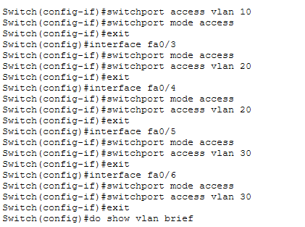
Step 4: Give fa0/24 trunk mode access
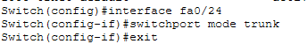

Step 5: ensure the vlan is as shown in the given fig

